**1.3 I can understand a range of tools and techniques and relate these to projects**

**Visual Studio (VS)**

VS is one of a range of text editors which can be used for coding the html/css for the website. There is a free and paid VS version of VS, though the free version has a large number of features and is certainly suitable for creating a website.

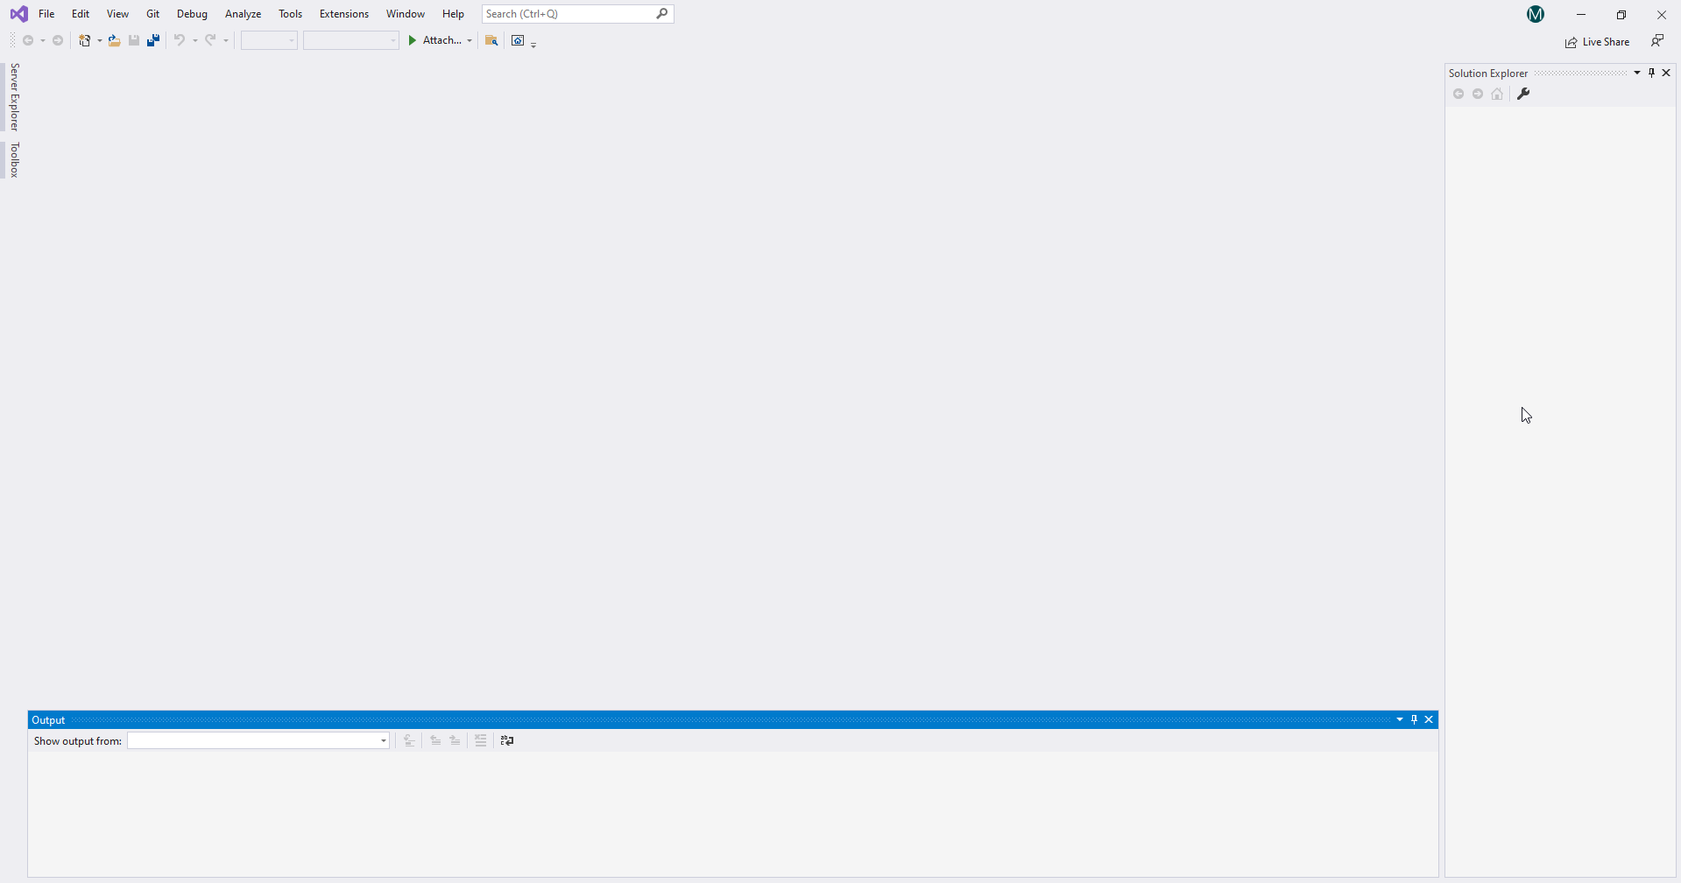

**Trello**

Trello is a means of using Kanban, one of the methodologies of the Agile process. Kanban is a means of organising into visual lists those tasks which need to, are being, and have been done. This could be used in the creation of a website to help one to know where you are in the project. Here is a picture taken from Trello.com:

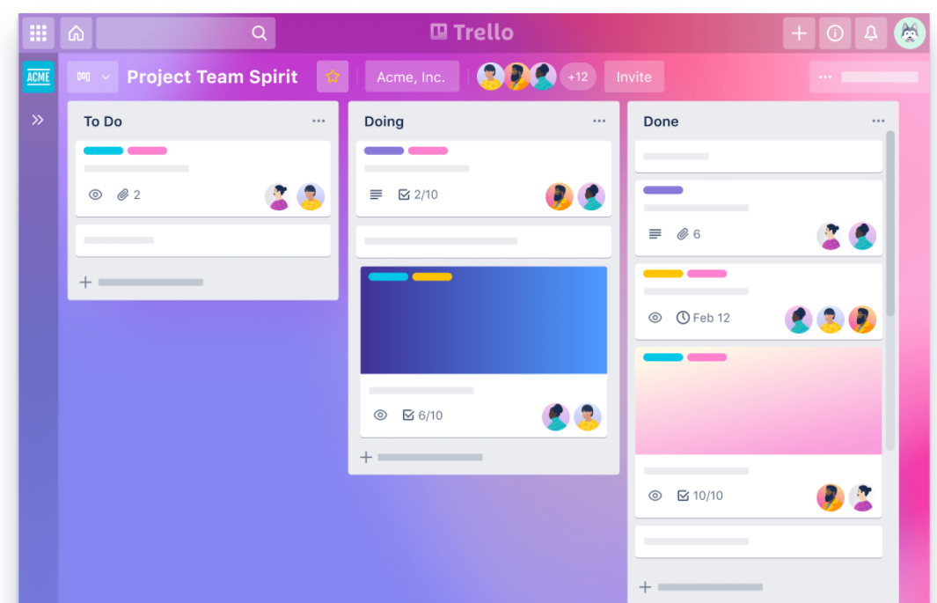

**SCRUM**

Scrum is a popular means of managing the development of a software application with Agile in mind.

With scrum, the product owner, such as someone wanting a website, selects a development team which are self-organised. The team selects a scrum master and then creates a product backlog, which contains the work to be done. The tasks are then done in what is called *sprints* with regular updates and releases depending on work that has been done, until the website is finished or cancelled.

This image is taken from Scrum.org:

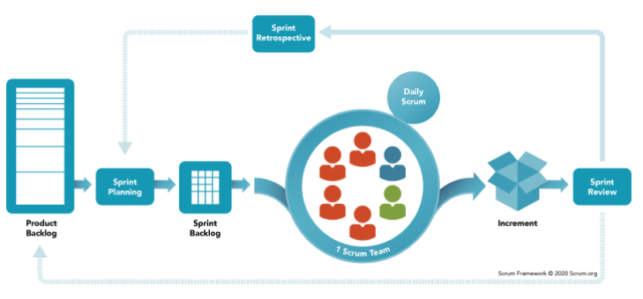

**A knowledge of html and CSS**

A knowledge of html and CSS is required for coding, or for the creation of the website content. One tool to turn code into a website is Visual Studio, shown above. If one was not reasonably competent in html or CSS then one would need to learn or delegate the task to someone else, which will increase the time taken to complete the project.

**Graphics**

There are a variety of sources of images and image editing tools that are available, which may need to be used to correctly format images being added to the website. Depending on the amount of correcting which is required, if one was not knowledgeable in a graphics editor again one may have to delegate this to someone else, increasing time and the cost of the website.

**Sound**

If the website is to have audio or video then there are a number of free and paid sources, such as Audacity/ Youtube, as well as Abelton or Harmonix. This image is taken from Audacityteam.org:  
  
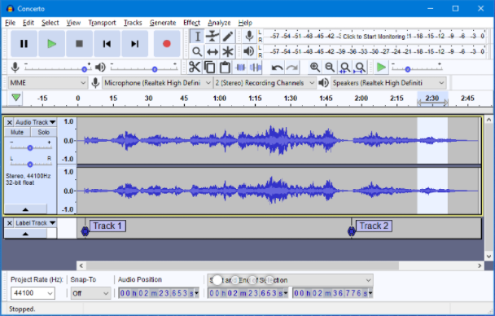

**Internet browser**

A modern internet browser such as Chrome/ Firefox/ Edge/ Safari will be required to both access the website, and test how the website performs before its completion.

**Hardware**

To both do the work making a website and to know if it were accessible one would need at least a laptop/ Macbook if not a desktop computer. Something smaller such as a tablet may not be comfortable for such intensive use, though it would depend on the task being done at the time.